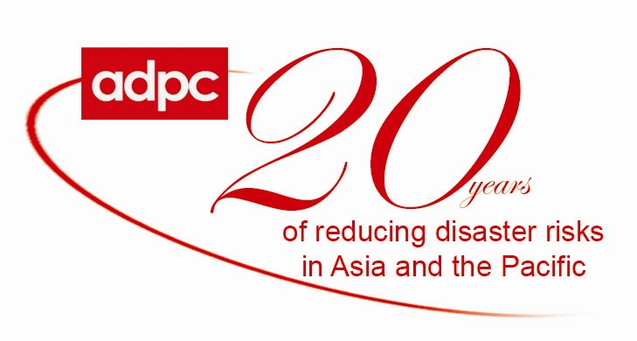

Report on Participate in the International Disaster Reduction Conference Harbin, China, 21 –25 August 2007

As per an invitation with funding support from Oxfam Hong Kong, Dr, Ranasant Selvaraju and Ms. LingLing Jiang attended the International Disaster Reduction Conference (IDRC), which was conducted in Harbin, China from 21 – 25 August 2007.

Dr. Selvaraju delivered a presentation related to Programmatic Disaster Risk Management: A Theoretical Framework that Integrates Climate Change in a special workshop that was organized by Oxfam Hong Kong in a framework of the Conference, and Dr. Selvaraju’s presentation impressed the participants.

During the Conference in Harbin, ADPC facilitated a meeting between China’s Ministry of Civil Affairs (MoCA) and Oxfam Hong Kong/Oxfam Hong Kong China Unit and ADPC in order to discuss together on collaboration on disaster risk management in China. Three parties agreed to work closely for disaster risk management in China, and they all were satisfied for such a result made during the Conference. A MoU between three parties will be prepared after the Conference.

