OPEN FORUM
Psychosocial Response to Disasters
Focus on Children in Asia

Organized by

Asian Disaster Preparedness Center (ADPC)

In collaboration with

Children and War Foundation and Norwegian Geotechnical Institute (NGI)

Sponsored by the Norwegian Ministry of Foreign Affairs

26 January 2010, 9:00 am - 4:00 pm
Queen’s Park 3 Meeting Room, 2nd Floor
Imperial Queen’s Park Hotel, Bangkok, Thailand

Profile of the Speakers and Moderator

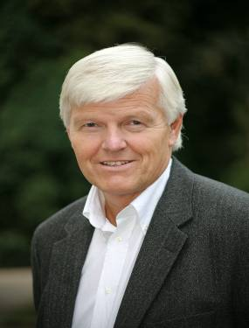 | ATLE DYREGROV, PhD  Director  Center for Crisis Psychology  Bergen, Norway  Email: atle@uib.no  Atle Dyregrov is a clinical and research psychologist and is a board member of the Children and War Foundation and one of the founders of the European Society for Traumatic Stress Studies. His former positions include 4 years of clinical and research work at the Children's Hospital in Bergen, and 4 years at the University of Bergen. He is the author of numerous publications, journal articles and books including "Grief in children", “Grief in young children”, “Psychological debriefing: a leader’s guide for small group crisis intervention” “Effective Grief and Bereavement Support. The Role of Family, Friends, Colleagues, Schools and Support Professionals” (where his wife Kari Dyregrov is the first author) (all published in English). His new book “Children and Trauma” will be published in 2010 (Jessica Kingsley Publishers). In addition he has published many books in Norwegian, among those "Disaster psychology", "Grief and care within schools" (co-author: Magne Raundalen), “Children and war” (co-authored with Magne Raundalen), “Children on the Intensive Care Unit” (co-authored with several others) and “The little sleep book”. He has lectured extensively in the Scandinavian countries, as well as in Europe, the USA, Australia and Africa. He has worked as a consultant to different UN organizations and international NGOs. His clinical work has covered areas such as: grief reactions in parents following the loss of a child, grief and trauma in children, organizing psychosocial disaster assistance, Critical Incident Stress Debriefing work with disaster-workers and other helpers, and work with children in war and disaster situations.
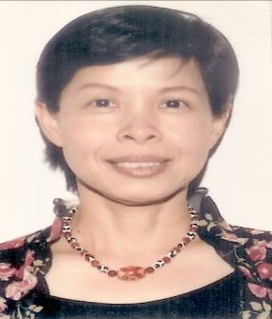 | DR. BENJAPORN PANYAYONG, M.D.  Senior Psychiatrist  Department of Mental Health  Ministry of Public Health  Nonthaburi, Thailand  Email: benja_panyayong@yahoo.co.uk / bpanyayong@gmail.com  Dr. Benjaporn Panyayong, M.D. is a child psychiatrist and senior child psychiatrist of the Department of Mental Health under the Ministry of Public Health of the Royal Government of Thailand.  Dr. Panyayong was the Director of Mental Health Recovery Centre, a unit set up for rehabilitation of the tsunami affected people during 2005-2006. She was one of the members of the Thai Medical Team for disaster relief mission in the Union of Myanmar after the Cyclone Nargis in 2008.  Dr. Panyayong was in charge as Head of Child Traumatic Stress Projects for children who were affected by continuous insurgency in the deep South of Thailand. Dr. Panyayong’s personal interest is in the area of school mental health and child protective services. She has involved as a member of the Sexual Abuse Network in cooperation with non–governmental organizations and other agencies and as a member of the Child Witness Training Program for social workers and psychologists in the Ministry of the Public Health of Thailand.  Dr. Panyayong authors a number of journal articles and books in the area of child trauma and also gives lectures in Thailand and other Asian countries.  Dr. Panyayong is a recipient of the Research Awards at the Royal College of Psychiatrist and The Psychiatric Association in Thailand and Medical Women Award of the Year from the Thai Medical Association in 2002
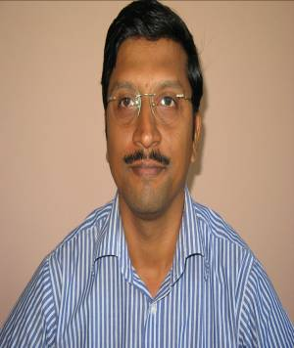 | DR. SATYABRATA DASH  Project Manager - Bangladesh Head of Office  Action Aid Australia  Cox's Bazaar, Bangladesh  Email: sdash@austcare.org.au / dr.satyabrata.dash@gmail.com  - Psychiatrist working in sector of Mental Health & Psychosocial Support and Social development since the last 9 years.  - Currently working with Rohingya Refugee camps in Bangladesh and the host communities for Action Aid Australia (formerly AustCare)  - Worked in post natural disaster projects on community based mental health and psychosocial support; designing and implementing country level programs during emergency as well as during recovery and rehabilitation for 5 years for the Red Cross Red Crescent Movement covering communities, schools and country level mental health referral systems.  - Has experience of working during emergency period in Maldives and Sri Lanka following the 2004 Tsunami. Has experience working with massive relocations and social integration in the Maldives and post disaster issues in Bangladesh.  - Has experience in working with prisoners in one of Asia’s largest prisons and with the mentally ill under protection of mental health legislation in closed mental health hospitals. Also, with issues of substance abuse.  - Has experience as mental health consultant in private sector hospitals.  - Has contributed towards development of policy documents, strategies and frameworks for countries and organizations.  - Has experience working in collaboration with partner organizations – governmental, non-governmental and UN agencies including academic institutions.  - Has been a training facilitator, training course designer in different countries in Asia for different organizations.  - Has compiled, edited and adapted training manuals and booklets on Mental Health and Psychosocial Support.  - Has multiple international research publications and presentations.  - Has training for managing Psychosocial Support Section of Emergency Response Unit (ERU).  - Has worked in 4 countries in South Asia – India, Sri Lanka, Maldives and Bangladesh.
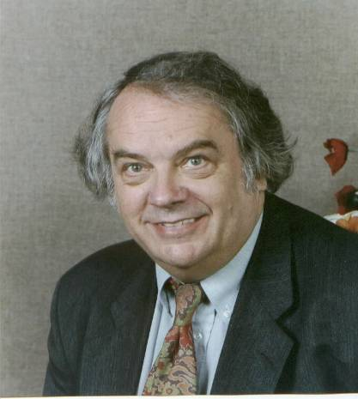 | PROF. WILLIAM YULE  Professor Emeritus  Applied Child Psychology  Institute of Psychiatry, King's College London  United Kingdom  Email: william.yule@kcl.ac.uk  PROFESSOR EMERITUS WILLIAM YULE is a clinical psychologist and Professor Emeritus of Applied Child Psychology at the Institute of Psychiatry, King's College London. He was the former Head of Clinical Psychology Services The Bethlem Royal and Maudsley Hospital in London. He is Chair of the Children and War Foundation and Honorary Psychologist Advisor to the British Army. He was awarded the Lifetime Achievement Award by the International Society for Traumatic Stress Studies in 2005.
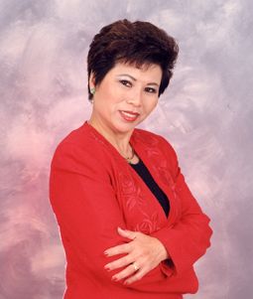 | He trained as a clinical psychologist at the Institute of Psychiatry and Maudsley Hospital in London. He spent six years in educational and epidemiological research before returning to the staff at the Institute of Psychiatry. He received his doctoral degree for his studies of specific reading retardation, part of the Isle of Wight epidemiological studies. He has published over 300 articles and 9 books on a wide range of topics in child psychology.  He has researched into training parents of autistic children to use behavioral techniques; training teachers to use behavioral techniques in mainstream classrooms; treatment of school phobia; longitudinal studies of the epidemiology of children's disorders; the effects of lead on children's development; children's fears. He is a founder member of the Society for the Study of Behavioral Phenotypes, a society devoted to the better understanding of the genotype/phenotype link in certain mentally handicapping disorders.  For the past thirteen years, he has been heavily involved in the study and treatment of PTSD in both adults and children. He has studied the effects of the capsize of the cross-channel car ferry, Herald of Free Enterprise and the sinking of the cruise ship, Jupiter, in Athens harbor. He has shown that PTSD is both a commoner and more chronic reaction in children and adolescents than had hitherto been suspected. Since the summer of 1993, he has been an advisor to UNICEF on its psychosocial programme for war affected children in former Yugoslavia and is Technical Director of a major programme to develop services for war affected children in Mostar in Bosnia. He has been active among British and European PTSD researchers He has currently developed links with researchers in the countries of the former Soviet Union and together with colleagues in Gent and Leiden is helping to set up training in clinical child psychology in the University of Kiev in the Ukraine.  He was Chair of the Association for Child Psychology and Psychiatry 1996-1999. He was elected to the Green Cross Foundation Academy of Traumatology in January 1998. He was appointed Honorary Consultant in Clinical Psychology to the Army in March 2000.  He was an expert witness in the Herald of Free Enterprise Arbitration and has appeared as an expert witness in Personal Injury cases in the High Court, in Child Care cases in Magistrates Courts and in the Family Division, in criminal cases in the Old Bailey. He takes instructions from both plaintiffs and defendants.  MS. LE LY HAYSLIP  Founder, Global Village Foundation, East Meets West Foundation  Author, When Heaven and Earth Changed Places, Child of War, Woman of Peace  MS. LE LY HAYSLIP is a globally-renowned writer and humanitarian. She is an award-winning author of two memoirs chronicling her extraordinary life in Vietnam and America: When Heaven and Earth Changed Places and Child of War, Woman of Peace. These books served as the basis for the 1993 Oliver Stone film Heaven and Earth. Having survived the torture and victimization of war herself, she has turned her personal struggle into a public passion to make a difference both in Vietnam and in the United States, as a humanitarian, a memoirist, and a powerful peacemaker.  She is the Founder of the Global Village Foundation, which focuses on humanitarian work and the promotion of non-violence and peace. It works with children in the aftermath of disasters, funds and constructs schools, and provides cultural and vocational training centers in rural areas of Asia. The mission of the Foundation is to break generational cycles of poverty, illiteracy and hopelessness, while still preserving the unique heritage of rural Asia.  In 1988 she founded the East Meets West Foundation (EMW), which works with the people of Vietnam to build a peaceful and prosperous future. Currently the largest NGO working in Vietnam today, EMW has built a strong reputation for implementing high quality programs and projects that make a lasting impact on thousands of children and families living in poverty. The organization describes its goals as "improving the general health, welfare, and socio-economic condition of the people of Vietnam, and providing a solid base for the self-sufficiency of our programs, as well as the individuals they serve."  Her first book, When Heaven and Earth Changed Places: A Vietnamese Woman's Journey from War to Peace (Doubleday, 1989), tells the story of her early childhood and war-torn adolescence. The non-linear structure alternates between the narration of her life in Vietnam as a child and her first return to Vietnam and her family in 1986. The two stories are interwoven to show the cyclical nature of Hayslip's journey; both her physical journey and her emotional one.  Her second memoir, Child of War, Woman of Peace (Doubleday, 1993), continues the same themes. Set in the United States during the final years of the Vietnam War, Hayslip explores how she dealt with an alien culture and the realization that she may never be able to return to her family and native country.  Her tenacity, business skills and commitment to the cause of the people of Vietnam, and particularly the children of Vietnam, mean that eventually, she was able to found the East Meets West Foundation. This memoir documents not only her struggles and successes in the United States but also her growing need to help heal the pain caused by the Vietnam War in both the United States and in Vietnam.  In 1995, Le Ly Hayslip was honored by the California State Assembly award for her humanitarian and reconciliation activities.

