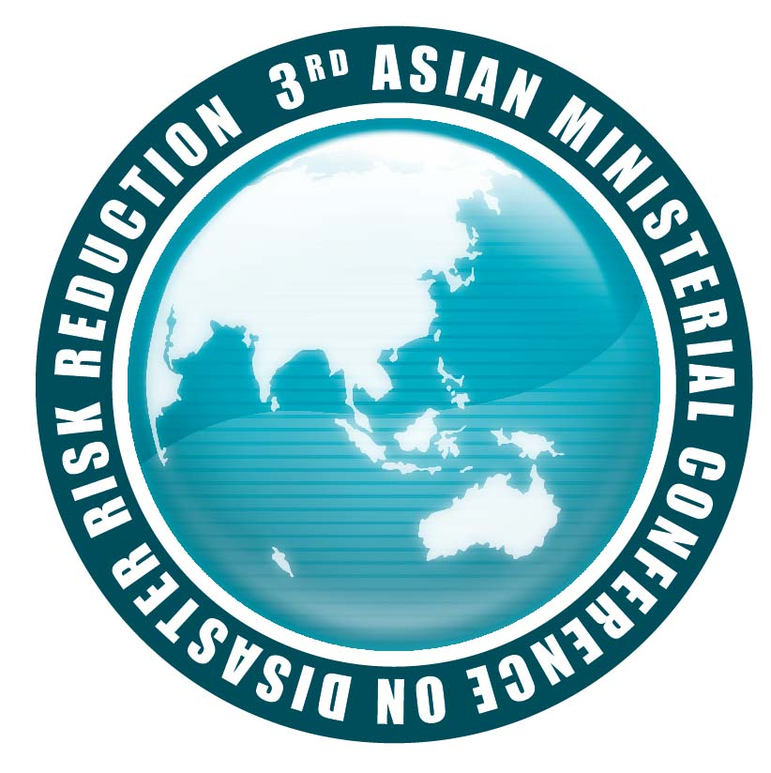
3rd Asian Ministerial Conference on Disaster Risk Reduction
2-4 December 2008 Kuala Lumpur, Malaysia

“Multi-stakeholder Partnership for Disaster Risk Reduction
From National to Local”

Concept Note

High Level Round Table 3 (HLRT-3) | Decentralization, Resource Allocation and Empowerment of Local Government and Communities for DRR
Schedule | 03 December 2008, (17 00 – 18 30 hr)
Theme to be addressed: | How to facilitate decentralization process and allocation of resources to local initiative, strengthen capacities for DRR at the City, Provincial and District Levels, Right based Community DRR
Organizers: | Session Leader - Asian Disaster Preparedness Center (ADPC)  Session Co-leaders  - Asian Disaster Reduction & Response Network (ADRRN)  - Duryog Nivaran  - International Federation for the Red Cross and Red Crescent Societies (IFRC)  - ALOKA  - Chinese Relief Society of Malaysia (CRSM)  - Malaysian Red Crescent Society  - University Putra Malaysia (UPM)
Background: | Emphasis on DRR action at the local government level is now becoming stronger as cities and towns of all sizes are subjected to rapid population growth, climate change, environmental degradation, and overall increased conditions of vulnerability. While urban areas currently attract more attention in reason of their high concentration of risk, medium and small-scale cities, towns, and local rural areas have an equally important role to play in reducing risks to disasters.  Throughout Asia, Community-based disaster risk reduction (CBDRR) has been recognized as one of the most successful bottom up approaches to address the needs and vulnerabilities faced by communities and to effectively enhance local capacities for response and risk mitigation.  It is at the local level that development planning is expected to first take place, and the integration between DRR and development is supposed to be realized. At the provincial, district and municipal level, local governments also serve the key function of ensuring a link between local, community-based organizations and central government authorities.  Unless community capacity and community-based practices are recognized, appreciated and adopted into the existing government policies and programs by national and local governments, disaster risks and vulnerability will continue to increase. Numerous calls exist recognizing the importance of communities in all aspects of DRR, including those made by the Beijing Declaration 2005, the Delhi Declaration 2007, and the results of the 7th Regional Consultative Committee (RCC) on Disaster Management.
Session Objectives: | - Discuss experiences of various countries on building political commitment for decentralization of DRR into local governments  - To discuss identify good examples of policy reforms required to facilitate decentralization processes and allocation of resources for DRR at the local government level  - To discuss the pros and cons of integrating rights-based and community-led DRR initiatives at local and provincial levels
Speakers and title of their interventions | Presentations will focus of the following key thematic focus:  - Integrating CBDRR into Local Governance; Hon. Governor Fauzi Bowo, Jakarta, Co-President of UCLG ASPAC  - ‘Decentralization of disaster risk reduction at provincial/ district/ local level - Institutional structures, policies, strategies and programmes – potentials and challenges’, H.E. Mr. Cao Duc Phat – Minster, Ministry of Agriculture &Rural Development, Government of Viet Nam  - Integration of CBDRR into local governance; Hon. Mahinda Samarasignhe, Minister of Disaster Management & Human Rights, Sri Lanka  - Challenges in Integrating Community Risk Reduction into Local Governance; Experience and Lessons Learnt from India; Mr. Shivraj V. Patil, Home Minister, Ministry of Home Affairs, India  - Recommendations from Technical Segment 03 to empower local governments, NGOs and CBDRR practitioners for integrating CBDRR into existing policies and programs at local levels - Mr. Loy Rego, Co-chair of Technical segment 03
Possible Key recommendations | A set of recommendations with particular reference to the governance structures in Asia on decentralized disaster risk reduction, which can be followed up and monitored at the biannual ministerial meetings and HFA reporting process.

Note: The speakers of the session to be confirmed

